**Service-Oriented Architecture**

Service-Oriented Architecture (SOA) is a software design paradigm that promotes the development of software systems as a set of loosely coupled services that can be reused and combined in different ways. SOA is based on the idea that software applications should be composed of services, which are self-contained units of functionality that can be accessed and consumed by other applications. It's a way of organizing and utilizing software components (services) in a modular and loosely coupled manner, with the primary goal of enabling interoperability, flexibility, and reusability.

**Key Concepts of SOA:**

* Services: At the core of SOA are services, which are self-contained, reusable software components that provide specific functionality. Services can be as simple as a function or as complex as a complete application.
* Loose Coupling: SOA promotes loose coupling between services. Services interact with each other through well-defined interfaces, making them independent and interchangeable. This reduces the impact of changes in one service on other services.
* Interoperability: SOA emphasizes interoperability, enabling services to communicate seamlessly across different platforms, languages, and technologies. This is crucial for integrating heterogeneous systems.
* Reusability: Services are designed to be reusable, which reduces development effort and leads to more efficient and cost-effective software solutions.
* Standardized Interfaces: Services expose standardized interfaces, often using technologies like XML or JSON, making it easier for different systems to understand and interact with them.
* Service Registry: SOA may include a service registry where services can be discovered and located. This is especially useful in large-scale systems with numerous services.

**Architectural Components of SOA:**

* Service Provider: The entity that creates and offers services to other components in the architecture.
* Service Consumer: The entity that consumes or uses the services provided by service providers. This can be an application, system, or another service.
* Service Directory/Registry: A repository or directory where services are listed and can be discovered by consumers.
* Service Interface: A well-defined interface that specifies how the service can be invoked and what data is required.
* Service Contract: A formal agreement that describes the service, including its input, output, and behavior.
* Service Compositions: Complex services can be built by orchestrating multiple simpler services. These compositions can be reused and may provide higher-level functionality.

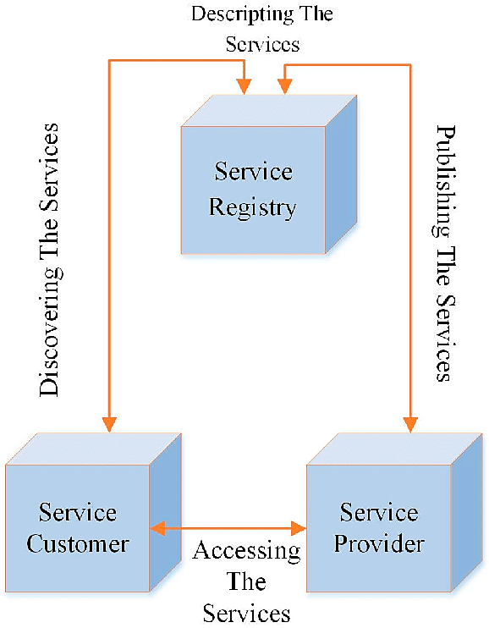

**Advantages of SOA:**

* Increased agility and flexibility: SOA makes it easier to develop and deploy new applications and services, and to modify existing ones. This is because SOA services are loosely coupled, meaning that they can be developed and deployed independently of each other. Services can be added, removed, or updated without impacting the entire system.
* Improved scalability and reliability: SOA applications are more scalable and reliable than traditional monolithic applications. This is because SOA services can be scaled up or down independently, and if one service fails, the others can continue to operate.
* Reusability: SOA services can be reused and combined in different ways across various applications and projects, which can eliminate the need to develop new code for every application.
* Reduced costs: Thanks to reusability, SOA can help to reduce the cost of developing and maintaining software applications and improve the return on investment.
* Interoperability: SOA allows systems to work together, even if they use different technologies and platforms.
* Legacy System Integration: SOA enables the integration of legacy systems with modern applications.

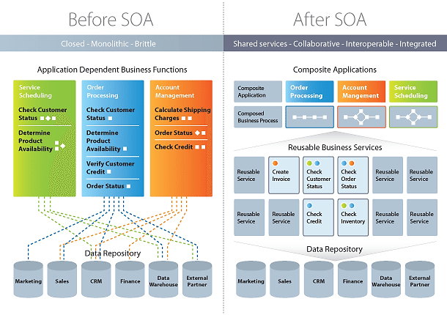

**Challenges of SOA:**

* Complexity: SOA can be a complex architecture to design, implement, and manage. This is because SOA systems typically involve a large number of loosely coupled services.
* Security: Ensuring secure interactions and protecting sensitive data is a concern in a distributed environment. SOA systems can be more vulnerable to security attacks than traditional monolithic applications. This is because SOA services are exposed to the network, making them easier to target by attackers.
* Performance: SOA applications can be slower than traditional monolithic applications. Overhead introduced by services and additional communication can impact system performance.
* Service Discovery: Efficiently discovering and managing services can be complex in large SOA environments.

**Use Cases of SOA:** SOA is widely used in a variety of industries, including healthcare, finance, and manufacturing. Some examples of SOA applications include:

* Order management systems: SOA can be used to develop order management systems that are composed of services for managing customer orders, inventory, and shipping.
* Customer relationship management (CRM) systems: SOA can be used to develop CRM systems that are composed of services for managing customer data, sales leads, and customer support.
* Enterprise resource planning (ERP) systems: SOA can be used to develop ERP systems that are composed of services for managing financial accounting, human resources, and supply chain management.
* Enterprise Application Integration (EAI): SOA is widely used to integrate diverse enterprise applications and systems within an organization.
* Web Services: Many web services and APIs are built on SOA principles, allowing third-party applications to interact with them.
* Cloud Computing: SOA principles are applied in cloud services to provide scalable and flexible solutions.
* Government Systems: Government agencies often use SOA to integrate various systems and provide online services to citizens.
* Telecommunications: Telecommunication companies use SOA to provide various services like messaging, billing, and customer management.

**Examples of SOA Standards and Technologies:** SOA is implemented using a variety of technologies and standards, including:

* Web services: Web services are the most common technology used to implement SOA services. Web services are self-contained units of functionality that can be accessed and consumed over the Internet.
  + SOAP (Simple Object Access Protocol): A protocol for exchanging structured information in the implementation of web services.
  + REST (Representational State Transfer): An architectural style for building web services using HTTP methods like GET, POST, PUT, and DELETE.
  + WSDL (Web Services Description Language): An XML format for describing web services and their interfaces.
  + UDDI (Universal Description, Discovery, and Integration): A standard for publishing and discovering services.
  + XML-RPC and JSON-RPC: Protocols for invoking methods on remote services using XML or JSON.
* Middleware:
  + Enterprise Service Bus (ESB): An ESB is a software middleware component that acts as a central hub for routing and managing messages between SOA services.  It is a software architectural pattern that supports real-time data exchange between disparate applications. Large organizations have multiple applications that perform various functions using diverse data models, protocols, and security restrictions.
  + EAI Middleware: Products like Apache Camel, MuleSoft, and IBM WebSphere that facilitate SOA-based integration.
* Business Process Management (BPM): BPM is a software discipline that focuses on the design, execution, and monitoring of business processes. BPM can be used to manage the interactions between SOA services to implement complex business processes.

**Implementing SOA:** Here are some tips for implementing a successful SOA:

* Start with a clear understanding of your business needs. What are the key business processes that need to be supported by your SOA system?
* Design your SOA system in a modular way, with loosely coupled services that can be reused and combined in different ways.
* Use an ESB to route and manage messages between SOA services.
* Use BPM to manage the interactions between SOA services to implement complex business processes.
* Implement appropriate security measures to protect your SOA system from attacks.
* Monitor the performance of your SOA system and make adjustments as needed.

SOA is a powerful architecture for developing and deploying complex software systems. It has significantly influenced modern software development and integration practices. Despite the challenges, SOA offers a number of benefits that make it a valuable architecture for developing and deploying complex software systems. It offers a flexible and scalable approach to building and connecting software components, making it an important paradigm in today's technology landscape.